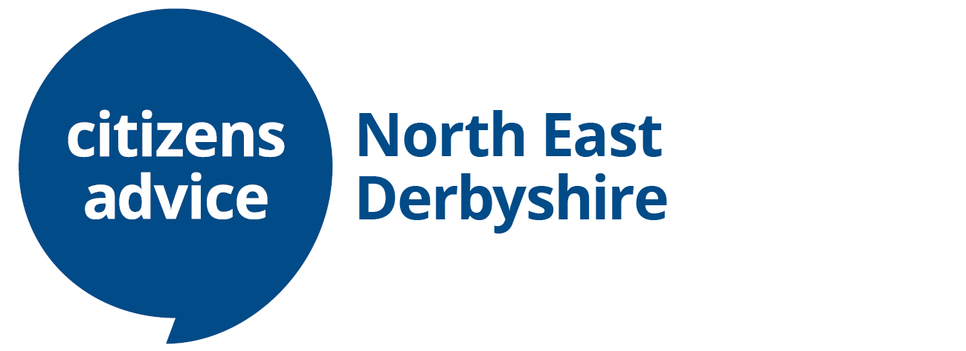

**BOOKING FORM**

PLEASE EMAIL [EVENTS@NEDCAB.ORG.UK](mailto:EVENTS@NEDCAB.ORG.UK) OR COMPLETE THE BELOW FORM WITH BOOKING DETAILS. Return forms to Citizens Advice North East Derbyshire, Coney Green Business Centre, Clay Cross, S45 9JW

**CHEQUES PAYABLE TO: CITIZENS ADVICE NORTH EAST DERBYSHIRE**

**BANK TRANSFERS TO UNITY BANK Account: Citizens Advice North East Derbyshire Registered Charity Number 1118194**

**Account Number: 20272915**

**Sort Code: 60-83-01**

**Reference: GALA50**

|  |  |
| --- | --- |
| **NAME** |  |
| **ADDRESS** |  |
| **CONTACT NUMBER** |  |
| **EMAIL ADDRESS** |  |
| **NUMBER OF TICKETS** |  |
| **TOTAL COST (£45 PER TICKET)** |  |
| **PAYMENT METHOD (DELETE AS APPROPRIATE)** | **CHEQUE ENCLOSED/BANK TRANSFER/CASH** |
| **DIETARY REQUIREMENTS/FOOD ALLERGIES** |  |